**ĐỀ THI TIẾNG ANH Mã đề: 17**

**Trình độ A2**

Họ và tên thí sinh: ……………..……………………………………………………….……………………………………………………………….

Số báo danh: ……………..…………………………………………...……. Phòng thi số: …………………………….…………………

**PAPER TWO LISTENING (Approximately 15 minutes)**

**PART 1: Questions 1 – 5**

*There are five questions in this part. For each question there are three answer choices and a short recording. Tick (***√***) the correct answer. You will hear the piece twice.*

*Example:* ***How many people were at the meeting?***

*A. 3 B. 13* **√** *C. 30*

**1.** Which T-shirt does the woman buy?

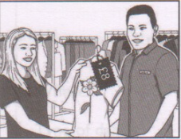 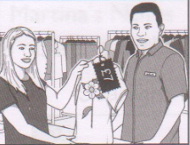 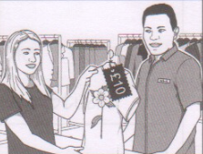

**A** □ **B** □ **C** □

**2.** When is the girl’s swimming lesson next week?

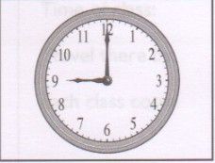 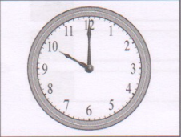 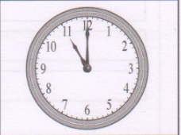

**A** □ **B** □ **C** □

**3.** Which bus stop does the woman need?

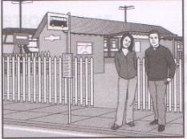 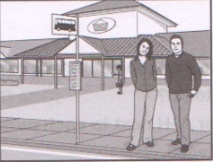 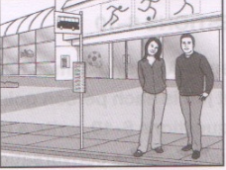

**A** □ **B** □ **C** □

**4.** Which is the man’s raincoat?

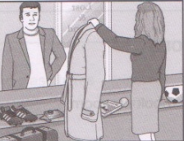 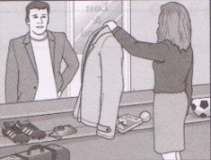 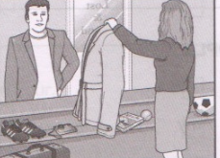

**A** □ **B** □ **C** □

**5.** Which is the office manager?

 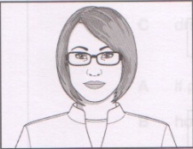 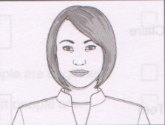

**A** □ **B** □ **C** □

**PART 2:** **Questions 6-10**

*Listen to Amy and James talking about planning a birthday party. What job is each person going to do? For questions 6-10, write a letter A-H next to each person. You will hear the conversation twice.*

|  |  |  |
| --- | --- | --- |
| **EXAMPLE** | **ANSWER** |  |
| **0**  Chris | **F** |  |
| **PEOPLE** |  | **JOBS** |
| **6**  Amy  **7** James  **8**  Claire  **9**  Tom  **10** Jane |  | **A** book the room  **B** buy a present  **C** buy party food  **D** get drinks  **E** invite guests  **F** make cake  **G** plan the music  **H** put up baloons |

**PART 3:** **Questions 11-15**

*Listen to Jessica talking to Frank about a dance class*

*For questions* ***11-15****, tick (√)* ***A****,* ***B****, or* ***C****. You will hear the conversation twice.*

Example: **0.** What time does the class start?

A. 7.30 pm

√ B. 8 pm

C. 9 pm

**11.** The class takes

A. half an hour

B. three quarters of an hour

C. an hour

**12.** What doesn’t Frank need to take?

A. trainers

B. sport clothes

C. drinks

**13.** The teacher needs to know

A. if people are beginners

B. how fit people are

C. people’s age

**14.** The normal price of classes is

A. £5

B. £6

C. £8

**15.** They will meet

A. at Jessica’s house

B. at college

C. in the cafe